Result report

HW #6_A (Uniform flat-top beam) result

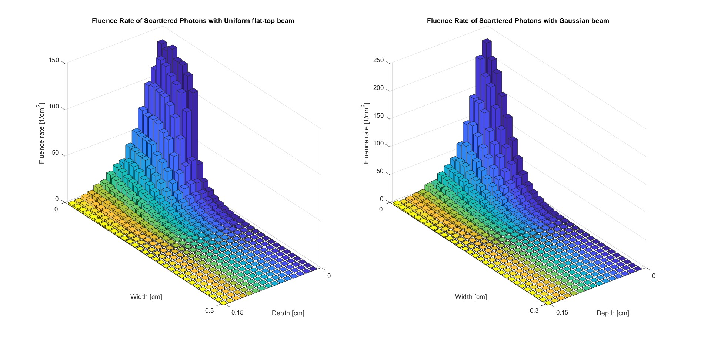

HW #6_B (Gaussian beam) result

